

Picture1

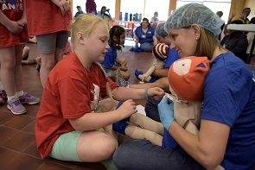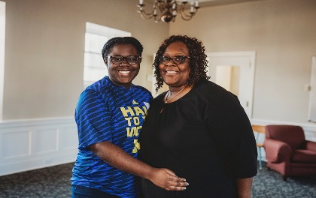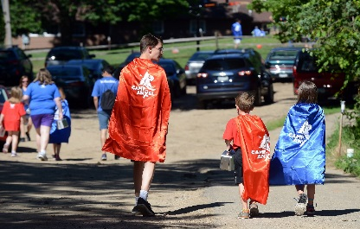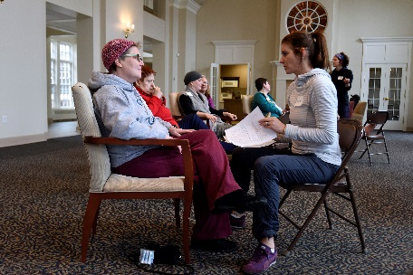

Hello!

Thank you for your interest in planning an event to benefit   
Angel Foundation! I hope that these templates will help you with some of your planning. Included in this packet, you will find a Flyer, a Save the Date, an Invitation, and a Post-Event Follow Up that have been created using Angel branding. Feel free to use any or all of these templates and edit them as you wish—they are meant to be a starting place as you begin to share the details about your event! As always, please know that I am here to be a resource or guide throughout your   
planning process—don’t hesitate to reach out with any   
questions!

- Megan  
[mgooselaw@mnangel.org](mailto:mgooselaw@mnangel.org)  
612-627-9000 ext. 512



Event Name

When cancer strikes, Minnesota-based 501(c)3 Angel Foundation provides support to local families through its two programs: Facing Cancer Together and Emergency Financial Assistance. Facing Cancer Together focuses on how cancer affects the entire family, providing consults, online resources, and year-round therapeutic programs. Emergency Financial Assistance provides assistance for basic, non-medical living expenses to local adults in active treatment for cancer.

Learn more about Angel Foundation at mnangel.org

Registration Details:

[Ticket Price]

[How to buy tickets (link to website, Facebook page, etc.)]

For additional information, please contact [contact information]

Insert pictures, logos, etc. here!

What: [Brief description of the event]

Where: [Event location]

When: [Date & Time of Event]

Why: [Why are you holding the event? To raise money for Angel Foundation, in someone’s memory or honor, etc.]



Save the Date!

Event Name

For additional information, please contact [contact information]

Could include an event logo, a picture from a past event, or the Angel Foundation logo here!

What: [Brief description of the event]

Where: [Event location]

When: [Date & Time of Event]

Why: [Why are you holding the event? To raise money for Angel Foundation, in someone’s memory or honor, etc.]

Angel Foundation is a Minnesota based 501(c)3 that provides financial assistance, education and support to local adults with cancer and their families. Learn more at mnangel.org



Join us!

What: [Brief description of the event]

Where: [Event location]

When: [Date & Time of Event]

Why: [Why are you holding the event? To raise money for Angel Foundation, in someone’s memory or honor, etc.]

Registration Details: [Cost of event, how to register]

Website: [if you have a website or Facebook page with more details, include the link!]

Event Name

For additional information, please contact [contact information]

Angel Foundation is a Minnesota based 501(c)3 that provides financial assistance, education and support to local adults with cancer and their families. Learn more at mnangel.org



Insert pictures, logos, etc. here!

See you next year!

$X raised for Angel Foundation!

Thank you note from organizers— can include information for next year’s event, link to event pictures, information about how many people attended etc.!

Thanks for coming!

Event Name